

Proposal to Provide Licensing Services

Prepared for ether.fi



February 25, 2026

FS Vector
1307 New York Ave NW
Washington, DC 20005
fsvector.com
(202) 864-6547

Table of Contents
Engagement Background | 2
About FS Vector | 2
Core FS Vector Offerings | 3
Relevant Experience | 4
FS Vector By The Numbers | 3
What Makes Us Different | 4
Representative Clients | 4
Engagement Scope | 4
License Acquisition | 4
License Maintenance | 7
Optional: Examination Support | 8
Optional: Independent AML Assessment | 9
Optional: Compliance Training | 9
Engagement Structure and Fee | 10
Staffing | 10
Timeline and Fee | 11

Engagement Background
ether.fi was founded in 2022 by Mike Silagadze and Rok Kopp to build a non-custodial ETH staking protocol for liquid staking that allows stakers to retain control of their keys while delegating validator operations to node operators. The ether.fi Foundation team believes decentralized, non-custodial staking is an essential and foundational good for Ethereum. The primary use case of $ETHFI is to govern the protocol and its activities. To power its products and growth in the US, ether.fi will apply for and acquire state money transmitter and digital asset licenses. FS Vector will support this important and strategic initiative.

FS Vector’s Fintech Advisory Team has unparalleled experience helping clients launch and scale in the United States through bank partnerships, license application and charter support, and developing operational compliance programs. FS Vector is the only licensing team that combines decades of licensing expertise with an automated licensing technology platform. In addition, our team has a range of other capabilities to assist with strategic and operational matters as they arise. Since our founding seven years ago, our team has helped over 600 companies launch their products, among a range of other engagements on strategic and operational matters.
About FS Vector
FS Vector is the go-to advisory firm with a range of service offerings for organizations innovating in financial services. FS Vector understands the needs of early, growth-stage, and large innovative firms, their partners, and financial institution supervisors. Our team’s track record and skillset drive smart solutions and a practical approach to addressing novel issues and achieving positive outcomes for our clients.


The Firm for Innovative Financial Services
fsvector.com

Core FS Vector Offerings

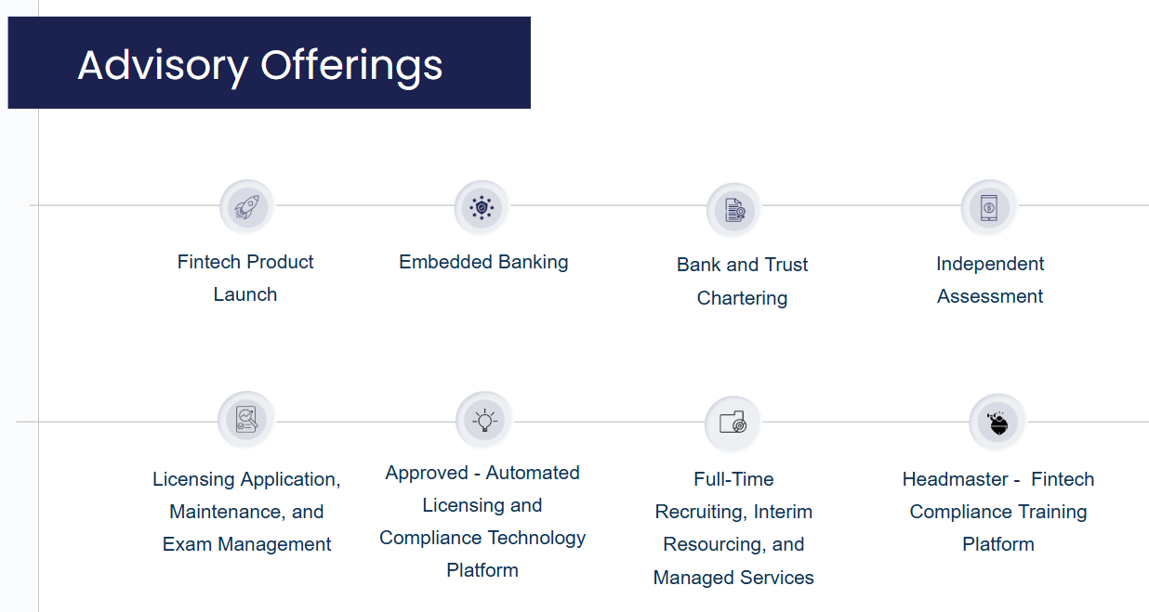

Relevant Experience

FS Vector By The Numbers
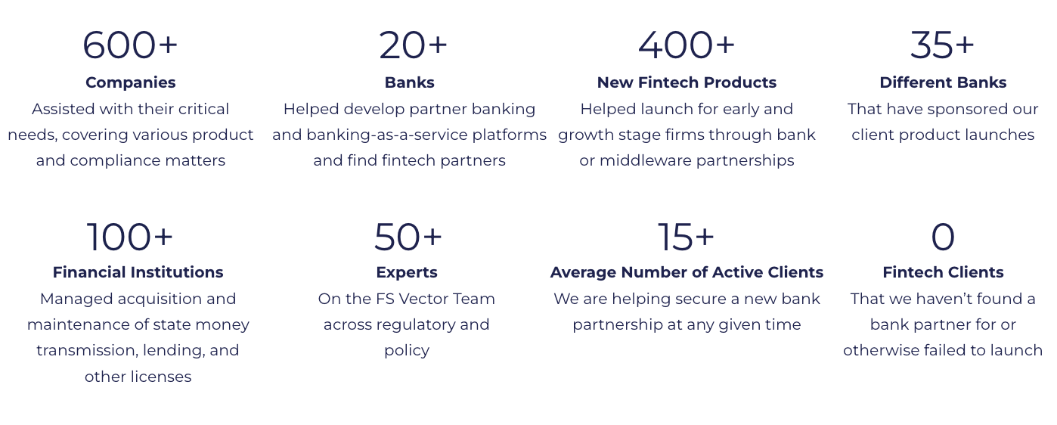

What Makes Us Different
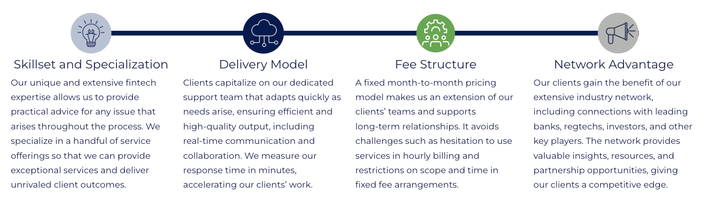
Engagement Scope
The below details the key components of the engagement:
- License Acquisition;
- License Maintenance;
- Optional: Examination Support;
- Optional: Independent AML Assessment;
- Optional: Compliance Training; and
- Optional: Managed Services.

License Acquisition
FS Vector will manage both license acquisition and maintenance on behalf of Ether.fi. FS Vector will be responsible for providing comprehensive support throughout the licensing application process, including assessing the specific licensing requirements for each state, preparing and submitting all necessary documentation, building or enhancing a licensing compliance program, liaising with state regulatory authorities, advising on product strategy as it relates to the licenses, and ensuring compliance with federal and state regulations.
We will leverage our licensing technology platform – Approved™ – that allows our team to track all if your licensing requirements and obligations against a nationwide database of state-by-state statutory requirements. Our licensing platform is powered by a proprietary, cross-industry requirements database built upon regulatory and licensing expertise and industry experience. Features of our licensing platform include:
- Dashboards organize critical information and track workloads across licensing teams, providing greater transparency and accountability.
- System tools and workflows increase accuracy and efficiency, enhancing the capacity of a company’s existing compliance function.
- Document-management functionality provides licensing teams with immediate access to accurate and relevant records and documentation.
- Data import capabilities that sync our licensing platform with the Nationwide Multistate Licensing System (NMLS) and other licensing systems to improve accuracy and create historical records for all licenses.
At a high level, we will follow the below approach to prepare and file applications for, and plan for maintaining, Ether.fi’s state money transmitter licenses. Throughout the process, FS Vector will work closely with Ether.fi staff to leverage internal resources, materials, and other information.

Phase 1: Initial Assessment & Licensing Strategy
Prior to the license acquisition kick-off, FS Vector will help Ether.fi to strategically design its US licensing and regulatory roadmap. The strategy phase will produce a state prioritization and phasing plan for Ether.fi’s license applications. The goal is to get license approvals as quickly as possible, which means developing a detailed application strategy.

Phase 2: Application Preparation & Product Strategy
The project documentation phase will include the creation, enhancement, collection or review of the following documents that are general requirements of the license applications, including the money transmission business plan, state registrations, surety bonds, fingerprints, and financial statements. The project will be managed by FS Vector’s licensing experts and within Approved, our licensing technology platform. We will advise on license application best practices, as well as sharing and utilizing templates for project management and other application materials.
We also begin two key workstreams during Phase 1:
- Business Plan & Product Strategy: FS Vector will provide Ether.fi with a template for the business plan and support drafting. We will also leverage Ether.fi’s existing materials from its non-US licensing. FS Vector will also provide guidance on the product strategy as it relates to leveraging its money transmission licenses and ensure that the business plan captures current products as well as roadmap features. We advise on different use cases, including with respect to structuring, user experience, and regulatory requirements, throughout the entirety of the engagement.
- License Compliance Program: We will kick-off the license compliance program documentation with a focus on the policies required to secure the licenses. FS Vector will provide templates for all required policies and will leverage existing licensing and compliance documentation where possible.

Phase 3: Pre-filing Meetings
This phase includes building relationships with regulators in key states, if needed, prior to the submission of an application. In this regard, we will focus on the following:
- Company Narrative. It is important to have a straightforward and consistent company narrative to serve as the foundation of each regulator meeting as well as Ether.fi applications. This narrative covers Ether.fi’ strategy broadly and makes clear “why now” and “how Ether.fi will execute”. We will work with you to develop, draft and present this narrative.
- Regulator Meetings. For key states, we will schedule, prepare for, and participate in pre-filing meetings as well as manage post-meeting follow-ups. Typically, California will require certain pre-filing activities before a full application is accepted.

Phase 4: File License Applications
This phase includes facilitating the compilation of all application materials and any other federal or state filings and submitting applications. At the outset we will have defined an application filing prioritization strategy, albeit with a goal of obtaining all required state licenses as efficiently as possible. We will assist with working through any challenges in collecting the necessary materials to provide for the timely filing of all applications.
Where necessary, we will work with Ether.fi’s non-Legal / Compliance internal stakeholders to prepare licensing materials. For example, we can support Ether.fi’ Product, Engineering, and Treasury teams in the preparation of product and funds flows, compliant reporting structures, and financial statements for the submissions.
FS Vector will support the NMLS documentation submissions as well as assist with filing any documents that are due outside of NMLS.

Phase 5: Application Follow-up & Related Compliance
This phase includes reviewing post-submission regulatory requests to identify areas where the application requires supplemental information. In this regard, we will assist with collecting additional information, preparing documents outlining the business plan or compliance program, and tailoring responses to meet regulatory expectations. In addition, we will participate in conversations with regulators regarding the submissions. To address application processing delays or state-specific application challenges or regulatory changes, we consider escalation points within the state banking department leveraging our relationships.
On an ongoing basis, we will assist with completing the application process. This process may include the following activities:
- Enhancing the licensing compliance programs, such as revising policies and procedures to reflect changes as requested by regulators;
- Support for operationalization of the licensing compliance program, including guidance on integration of policies and procedures into Ether.fi’ daily operations and providing practical, actionable advice on implementation of license compliance requirements;
- Provide guidance on enterprise training as it relates to the money transmitter licenses and payments compliance generally; and
- Providing advice on additional compliance and licensing related considerations, such as additional regulatory complexity and obligations that may arise as additional features, geographies, and customers are added to the platform.

License Maintenance
FS Vector can support the maintenance of Ether.fi’ licenses as each is secured. We will leverage the Approved licensing technology platform for Ether.fi’ maintenance, including by ensuring that it serves as a single source of truth for Ether.fi’ licensing documents and materials.
Our team will assist with the following tasks, providing hands-on support and advice:
- File monthly and quarterly reporting requirements;
- File annual license renewals;
- Maintain company and executive NMLS account(s) in accordance with applicable requirements, surety bonds in accordance with license requirements and handle surety bond vendor relationship;
- Monitor for updates to state licensing requirements and assist with responses to regulatory inquiries;
- Advise on compliance with state business license registrations in accordance with licensing requirements;
- Coordinate with internal stakeholders regarding their responsibilities in the license maintenance process, including legal, finance, product, and data teams;
- Advise on and support overall regulatory management, including drafting and filing Advance Change Notices (ACNs), regulatory outreach strategy in the context of new product development under the licenses, responding to ad hoc requests from regulators, and assisting with outreach to regulators generally;
- Provide general guidance for state examinations, with the option to engage with FS Vector’s examination specialists before, during, and post-examination;
- Provide general maintenance advice and guidance throughout the license maintenance process, including with respect to product development, succession planning, and license monetization strategy; and
- If Ether.fi chooses to conduct license maintenance entirely in-house, FS Vector can support the building and scaling of Ether.fi’s internal maintenance program and employee training.

Optional: Examination Support
Regulatory exams will be a fact of life for Ether.fi as a licensee. FS Vector can provide a variety of examination services to prepare for and manage the entire exam process. We mitigate compliance risk and ease operational burdens, minimizing disruption to Ether.fi’ business.
- Examination Preparation:
  - Assist with anticipated timing and scope of an examination based on licensing footprint;
  - Preparing for onsite examinations & develop presentation materials;
  - Access to examination playbooks to ensure overall readiness;
  - Draft mock responses to examination final reports on findings & observations; and
  - Performing mock examinations that include a full review of company information, documentation and advisory services in preparation of an examination.
- Information Management:
  - Increase productivity and efficiency to meet regulatory deadlines;
  - Support examination-record retention, continuous compliance monitoring, versioning and history;
  - Streamline communication management before, during and after examinations; and
  - House, monitor, and track findings or observations that result during the examination.
- Examination Management:
  - Organize, assign, and manage all examination requests to ensure timely and accurate responses through comprehensive task-management tools;
  - Assist as a third-party user within the State Examination System or state specific portals;
  - Facilitate presentations, communications and document exchanges; and
  - Manage and track remediation to ensure all matters requiring attention are addressed, implemented, and routinely checked.

Optional: Independent AML Assessment
FS Vector can conduct an independent assessment of Ether.fi’s Anti-Money Laundering (AML) and sanctions control program (“AML Program”). To best serve Ether.fi’ current needs, FS Vector will take a two-phased approach to the work:
- Pre-Launch Design Effectiveness Review: Pre-Launch FS Vector will evaluate the design of the AML Program to ensure the program meets regulatory and/or partner requirements.

Phase 1 Deliverable: FS Vector will summarize the results of the first phase in a report that will include our overall conclusion as to the design effectiveness of the AML Program. The report will describe any findings arising from the assessment and will provide a rating of the relative importance of the findings for management action. The phase 1 report will form as the foundation to the phase 2 effort.

- Post-Launch Operating Effectiveness Review: Approximately six months post-launch, when sufficient transaction, customer and other live program data is available, we will refresh the design effectiveness evaluation and perform file and transaction sampling to test the operating effectiveness of the AML Program.

Phase 2 Deliverable: FS Vector will summarize its assessment in a report that will include our overall conclusion as to the health of the AML Program. The report will describe any findings arising from the program assessment and will provide a rating of the relative importance of the findings for management action.

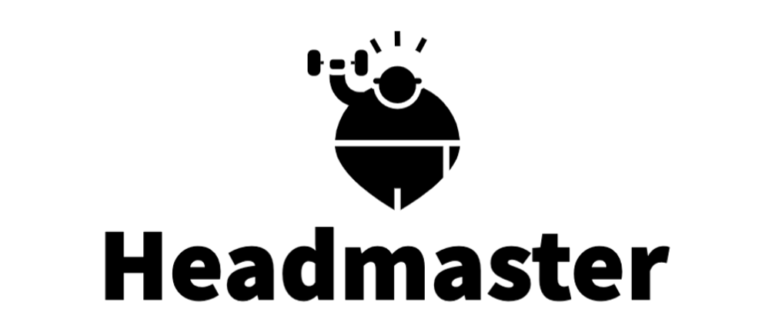
Optional: Compliance Training
Headmaster is the only compliance training and learning management software built specifically for fintech companies. It includes a comprehensive regulatory training program tailored to meet the requirements of US MSBs. The content and platform are designed to meet bank partner requirements and has been built to go beyond checking a box and building a culture of compliance.
The platform also includes the following components:
- Online training courses covering areas such as: AML, Complaint Management, Deceptive Practices, Business Continuity, Privacy, Fair Lending, and much more.
- Periodic Headmaster Briefings containing regulatory updates, best practice guides, and other materials.
- Assessments including quiz questions and other tests.
- Compliance tracking and reporting of employee completion data.

Engagement Structure and Fee

Staffing
Our goal is to be a trusted advisor, develop long-term partnerships, and ensure our clients meet their goals. In this regard, we provide flexible engagements that align with our clients’ needs and timelines, while also providing certainty for budgeting purposes. Throughout the engagement, FS Vector will work closely with Ether.fi to discuss project goals and timelines, including right-sizing the engagement post-launch. FS Vector will establish a Slack channel to collaborate with Ether.fi daily and meet with Ether.fi staff weekly over video conferencing calls.
FS Vector’s Licensing engagement team will utilize Approved, our licensing technology platform, to power the licensing project. David Cotney, Senior Advisor and former Massachusetts Commissioner of Banks and Chairman of the Board of Directors of the Conference of State Bank Supervisors (CSBS), will also helps support the engagement. We will leverage our strong and deep relationships with both the state regulators and banks. Team bios are provided here.

(continued on the next page)

Timeline and Fee
Licensing
Below please find the estimated timelines and range of applicable fee to support the multi-state acquisition of licenses (fee depends on how many and which licenses the company will pursue) and maintain those licenses post-approval.

License Acquisition
Month | ~1 -10 | ~11-16 | ~17+
Key Steps | Step 1  Licensing Strategy & Outreach to States (Pre-Filing Meetings, if applicable)  Step 2  Applications Preparation  Step 3  Application Filings  Step 4  Application Follow-up & Responses  Step 5  Initial License Maintenance (first two licenses included) ** | Step 6  Application Follow-up & Responses  Step 7  License Maintenance**  Step 8  Examination Support ** | Step 9  Application Follow-up & Responses  Step 10  Implement Expanded Maintenance **  Step 11  Examination Support **
Monthly Fee | $25,000 - $40,000 / month | $20,000 - 25,000 / month | Estimated $8,000-$15,000 / month (we will work with Ether.fi to determine the appropriate monthly fee based on what is outstanding)

** Please see below for information regarding License Maintenance and Examinations.

License Maintenance
Month | 1 - 2 | 3 - 5 |  | 6 - 7 | 8+
Maintenance Assessment & Program Build | - Initial maintenance assessment and validation exercise (focused on definitions, training, reports, and data feeds)  - Reports / Renewals | - Address recommended key actions (cont.)  - Implement maintenance program; core maintenance  - Reports / Renewals | - Core maintenance  - Reports / Renewals |  |  | - Ongoing core maintenance, including examinations  - Ongoing monitoring of state licensing developments  - Medium- and longer-term product development and license monetization strategy  - Reports / Renewals
Fee (annual contract; billed monthly) | 1-year contract: $160,000 - $215,0000 / year (depending upon scope of services)  Multi-year contract discount apply

Independent AML Assessment (optional)
FS Vector can perform an independent AML assessment for a fixed fee of between $40,000 - $60,000 according to the structure below:
 |  | Independent Assessment
Stage | Initiation  Kickoff and initiation of the Assessment |  | Completion  Delivery of draft report
Fee | $20,000 - $30,000 |  | $20,000 - $30,000

Examinations (optional)
We offer a variety of support structures for examinations which can be combined or requested individually, at the request of Ether.fi. Below is a sample of the services and fees.
Examinations
Exam Service Type | Fee Type |  | Typical Fee Ranges
Forecasting Materials | Flat Fee | $25K - $45K
Single State Mock Exam | Flat Fee | $60K - $140K
Multistate Mock Exam | Flat Fee | $80 - $180K
Targeted Review / Mock Exam | Flat Fee | $25K - $40K
Full Examination Support (may be virtual or on-site) | Flat Fee | $75K - $400K

Ether.fi can utilize FS Vector’s proprietary training platform, Headmaster™, to meet its MSB training requirements.

